Eric Gilmore, Interim Director
Department of Public Safety

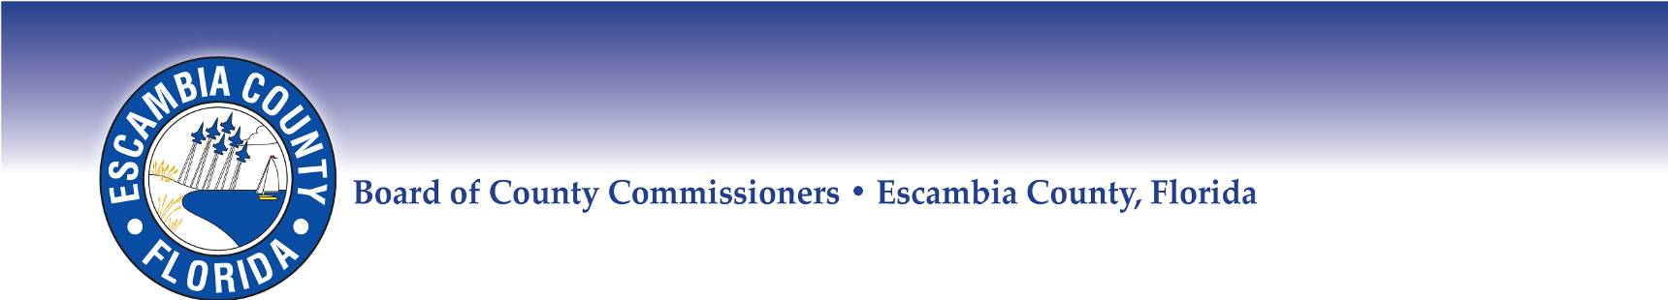

2021
Escambia County
Hurricane Shelters

Global Learning Academy
100 North P Street
Pensacola, Florida 32505

Jim Bailey Middle School
4110 Bauer Road
Pensacola, Florida 32506

Molino Park Elementary School-Pet Shelter
899 Highway 97
Molino, Florida 32577

Northview High School
4100 West Highway 4
Century, Florida 32535

Pensacola Bay Center
201 East Gregory Street
Pensacola, Florida 32502

Beulah Middle School
6001 West Nine Mile Road
Pensacola, Florida 32526

Special Needs Shelter:
Success Academy
(old West Florida High)
Buildings 9, 25 & 26
7045 Wymart Road
Pensacola, Florida 32526

