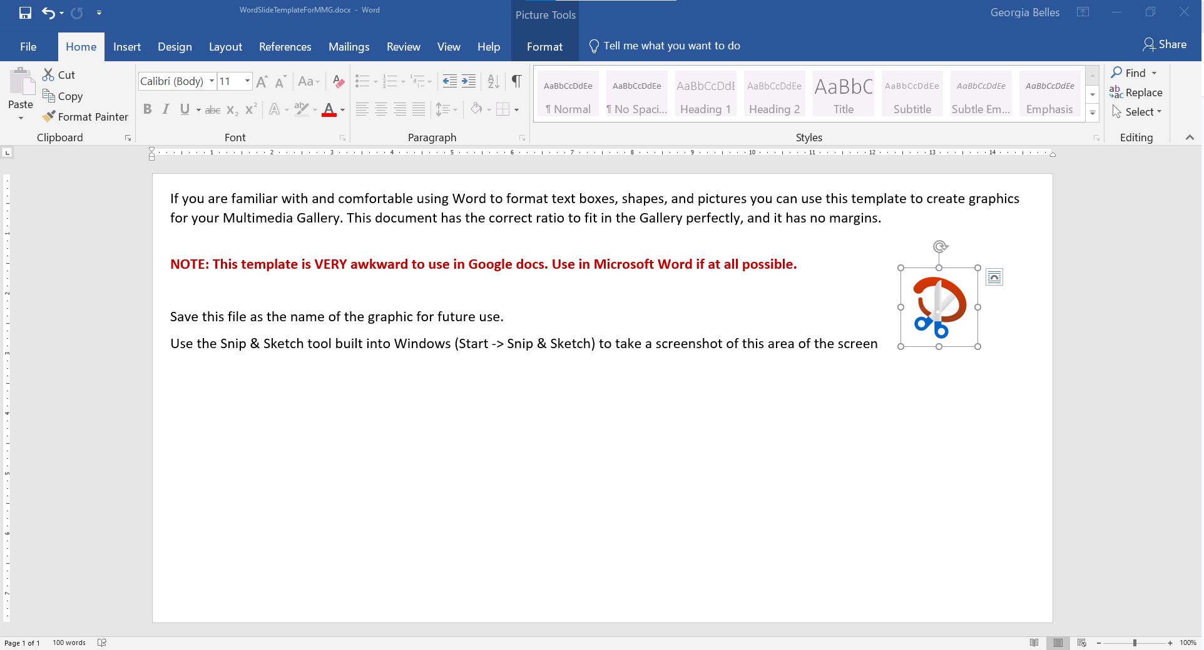

Haven’t used the Snip & Sketch tool yet? It’s amazingly handy! Here’s a brief tutorial video: <https://www.youtube.com/watch?v=OO0aS7gh3Rg>

If you are familiar with and comfortable using Word to format text boxes, shapes, and pictures you can use this template to create graphics for your Multimedia Gallery. This document has the correct ratio to fit in the Gallery perfectly, and it has no margins.

**NOTE: This template is VERY awkward to use in Google docs. Use in Microsoft Word if at all possible.**

Save this file as the name of the graphic for future use.

Use the Snip & Sketch tool built into Windows (Start -> Snip & Sketch) to take a screenshot of this area of the screen  
(see picture below – draw the screenshot area where the red box is.) Save the result as a .png file.

Upload the picture into your Multimedia Gallery and you’re good to go!

If you have questions email Georgia Belles at gbelles@ecsdfl.us